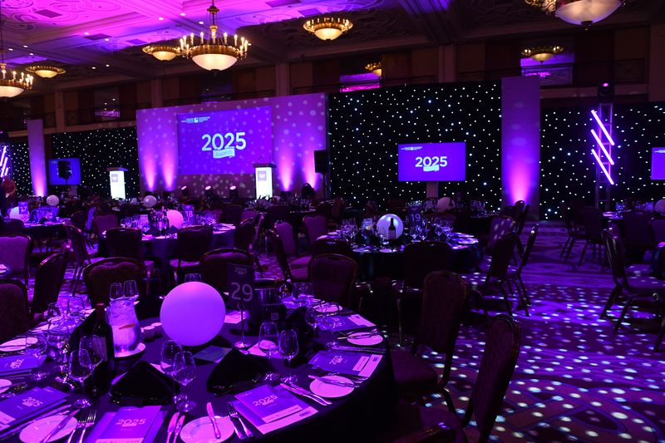
CEW Awards 2026
12th June, Celtic Manor Resort - 6.15pm to 11.30pm

Dinner Booking Form

NB 5% EARLY BIRD DISCOUNT FOR MEMBERS IF BOOKED BEFORE 31ST MARCH

Contact Details | Name: Click here to enter text.  Position: Click here to enter text.  Email: Click here to enter text.  Organisation: Click here to enter text.  Invoice address: Click here to enter text.

CEWales Member individual tickets @ £150 plus VAT | ☐ 1 ticket ☐ 2 tickets ☐ 3 tickets ☐ 4 tickets
CEWales Member table of 10 @ £1500 plus VAT | ☐ 1 table ☐ 2 tables ☐ 3 tables
CEWales Non-Member individual tickets @ £190 plus VAT | ☐ 1 ticket ☐ 2 tickets ☐ 3 tickets ☐ 4 tickets
CEWales Non-Member table of 10 £1900 plus VAT | ☐ 1 table ☐ 2 tables ☐ 3 tables

Please complete all fields in this booking form and return to awardsdinner@cewales.org.uk
Please note:
- Payment must be made within 30 days of invoice and in advance of the dinner, tables are not confirmed until payment has been received.
- Names of all guests will be required 2 weeks prior to the dinner together with any dietary requirements. Dress code is black tie
- Discounted accommodation is available please email awardsdinner@cewales.org.uk to request a booking link

