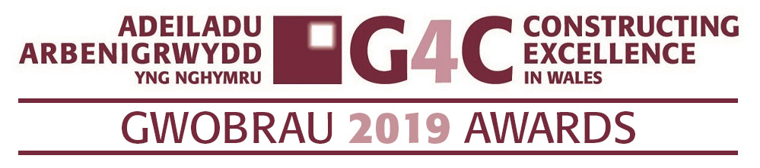
Entry Form
FUTURE LEADER AWARD

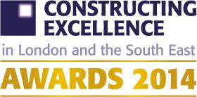
Ensure you read and understand the criteria and guidelines before completing this form. Guidelines and How to Enter can be found on the CEW website (www.cewales.org.uk). Importantly, please remember that:

- Information above the specified word limits may not be taken into consideration
- Photo’s and Logo’s in a high resolution format MUST accompany your entry (PDF’s CANNOT be accepted)
- Please submit your completed entry form via email to susan.selkirk@cewales.org.uk by midday Monday 17th June 2019.
Category Description: G4C Future Leader Award
G4C is a driving force for industry change, through the development and connection of future industry leaders. The award is open to a person with less than ten years of experience in the construction and built environment sector (typically less than 35 years of age).

Judges are looking for the person that best demonstrates a positive impact on their peers, their organisation and the wider industry, against current G4C priority areas of people development, sustainability and innovation.

Our winner will have shown potential to become an exemplary future leader, evidenced by a number of the following attributes:

- Being a leading thinker and champion for change.
- Ability to positively impact the behaviour of others.
- A collaborative approach to problem solving and delivery of outcomes.
- Creativity and ability to think differently, generate ideas and see them through to implementation.
- Ability to drive positive and sustained change for the benefit of their organisation, community and environment.

THE CONSTRUCTING EXCELLENCE AWARDS ‘RECOGNISE THE BEST AND INSPIRE THE REST’.
Is your submission special? We want to know if this individual is doing something that is new or different. It could be how they manage a specific process or a wide ranging programme. Or even encouraging their peers to further their careers.

Can you demonstrate real benefits? We want data. You needn’t submit all your information but we need to know that you have changed or achieved something through some measurable information.

Is it honest? We are not looking for marketing information. We want real stories which give an honest summary of all the issues that you have overcome to deliver.

G4C FUTURE LEADER AWARD

Is your entry? (a) a personal entry

(b) a nomination

G4C FUTURE LEADER AWARD
Main Contact (this relates to questions/queries about the entry) | Name: Tel No: Email:
Organisation & Office address
Telephone Number
Email Address of main contact
Name of Nominee
Position held

Current Employer
Type of organisation (i.e. housing association, developer, government department, contractor, consultant etc)

** Please remember to maximise the word count**

YOUR SUBMISSION. We encourage you to answer all sections, however it is not mandatory to complete
them all. If a section is not relevant, please explain why.
Overview:
Describe the individual’s role and the context of the submission.

Word limit up to 200 words
Leadership & influence:
How has the nominee’s performance of a leading thinker and champion of change influenced their own and performance of others. This could also include evidence of leadership attributes.

Word limit up to 250 words
Collaboration:
Evidence of nominee’s collaborative approach to problem solving and the delivery of outcomes, including the approach to building trusting, open relationships with team members and stakeholders across organisational boundaries.
Word limit up to 250 words
Innovation:
Evidence of nominee’s creativity and ability to think differently, generate ideas, gain buy-in and see them through to implementation, including the benefits achieved as a result.

Word limit up to 250 words
Sustainability:
Evidence of nominee’s awareness of sustainability, be it economic, social and/or environmental, and ability to passionately drive positive change and tangible outcomes for their organisation, community and environment.
Word limit up to 250 words
Legacy:
Evidence of nominee’s record in delivering sustained change, including the on-going benefits of the change achieved as a legacy to the industry, in line with the Construction 2025 objectives.

Word limit up to 250 words
Describe how the nominee has demonstrated a positive impact of acting as an intelligent client to their supply chain.

Word limit up to 250 words
Deadline for entries: Monday 17th June 2019 – via email to susan.selkirk@cewales.org.uk
If you have any queries, please contact Susan Selkirk
07553347099 or 02920 493322:

