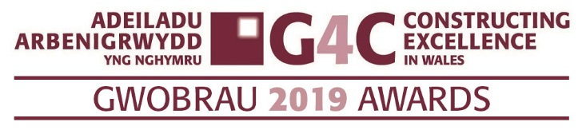
Entry Form
Commitment to Employee &
Training Development

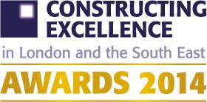

Ensure you read and understand the criteria and guidelines before completing this form. Guidelines and How to Enter can be found at www.cewales.org.uk. Importantly, please remember that:

- Information above the specified word limits may not be taken into consideration
- Photos and Logos in a high resolution format MUST accompany your entry (PDF’s CANNOT be accepted)
- Please submit your completed entry form via email to susan.selkirk@cewales.org.uk by midday Monday 17th June 2019.
CATEGORY DESCRIPTION – COMMITMENT TO EMPLOYEE & TRAINING DEVELOPMENT
This award is open for organisations who have demonstrated and sustained a commitment to employee development. Judges will be looking for a company who have a strategic plan that includes driving performance via professional development. Judges will be looking for companies who invest time and resources into their employees and set clear targets providing staff with regular appraisals and feedback. Organisations should promote development providing opportunities across the company. Organisations should best define and demonstrate improvements resulting from targeted training and development, whether driven by strategic leadership of an enlightened client or a supplier, entries should show and win particular respect from the workforce and community through workforce development, skills and training. Organisations should be striving to work towards the Construction 2025 vision as outlined below:

- PEOPLE – An industry that is known for its talented and diverse workforce
- SMART – An industry that is efficient and technologically advanced
- SUSTAINABLE – An industry that leads the world in low carbon and green construction exports
- GROWTH – An industry that drives growth across the entire economy
- LEADERSHIP – An industry that with clear leadership from a Construction leadership council.

THE G4C AWARDS ‘RECOGNISE THE FUTURE LEADERS OF THE INDUSTRY’
Is your submission special? We want to know if you are doing something that is new or different. Or if are you doing something that is common to the industry, but doing it better than anyone else. It could be how you manage a specific process or a wide ranging programme. It doesn’t need to be technologically cutting edge, but it does need to be exemplary.

Is it honest? We are not looking for marketing information. We want real stories which give an honest summary of all the issues that you have overcome to deliver.

Commitment to Employee &
Training Development

COMMITMENT TO EMPLOYEE & TRAINING DEVELOPMENT
Entry name
(Please keep this concise)
Applicant’s contact details | Name
 | Organisation
 | E-mail
 | Telephone
 | Address
 |  | Postcode:
Please provide a brief and compelling summary of what makes this organisation deserving of an award. (Please note this description may be used in the awards brochure) Word limit 200

** Please remember to maximise the word count**

YOUR SUBMISSION. We encourage you to answer all sections, however it is not mandatory to complete them all. If a section is not relevant please explain why.
How do you invest in training and upskilling your workforce?

Word limit up to 250 words

How have you encouraged talent and performance, and sought this among new entrants?

Word limit up to 250 words
How does equality and diversity play a part in your organisation’s development planning?

Word limit up to 250 words
What have you done to encourage employees and suppliers to be better benefactors to local communities, the environment and the industry’s image?

Word limit up to 250 words

Deadline for entries: Monday 17th June 2019 – via email to susan.selkirk@cewales.org.uk
If you have any queries, please contact Susan Selkirk
07553347099 or 02920 493322:

