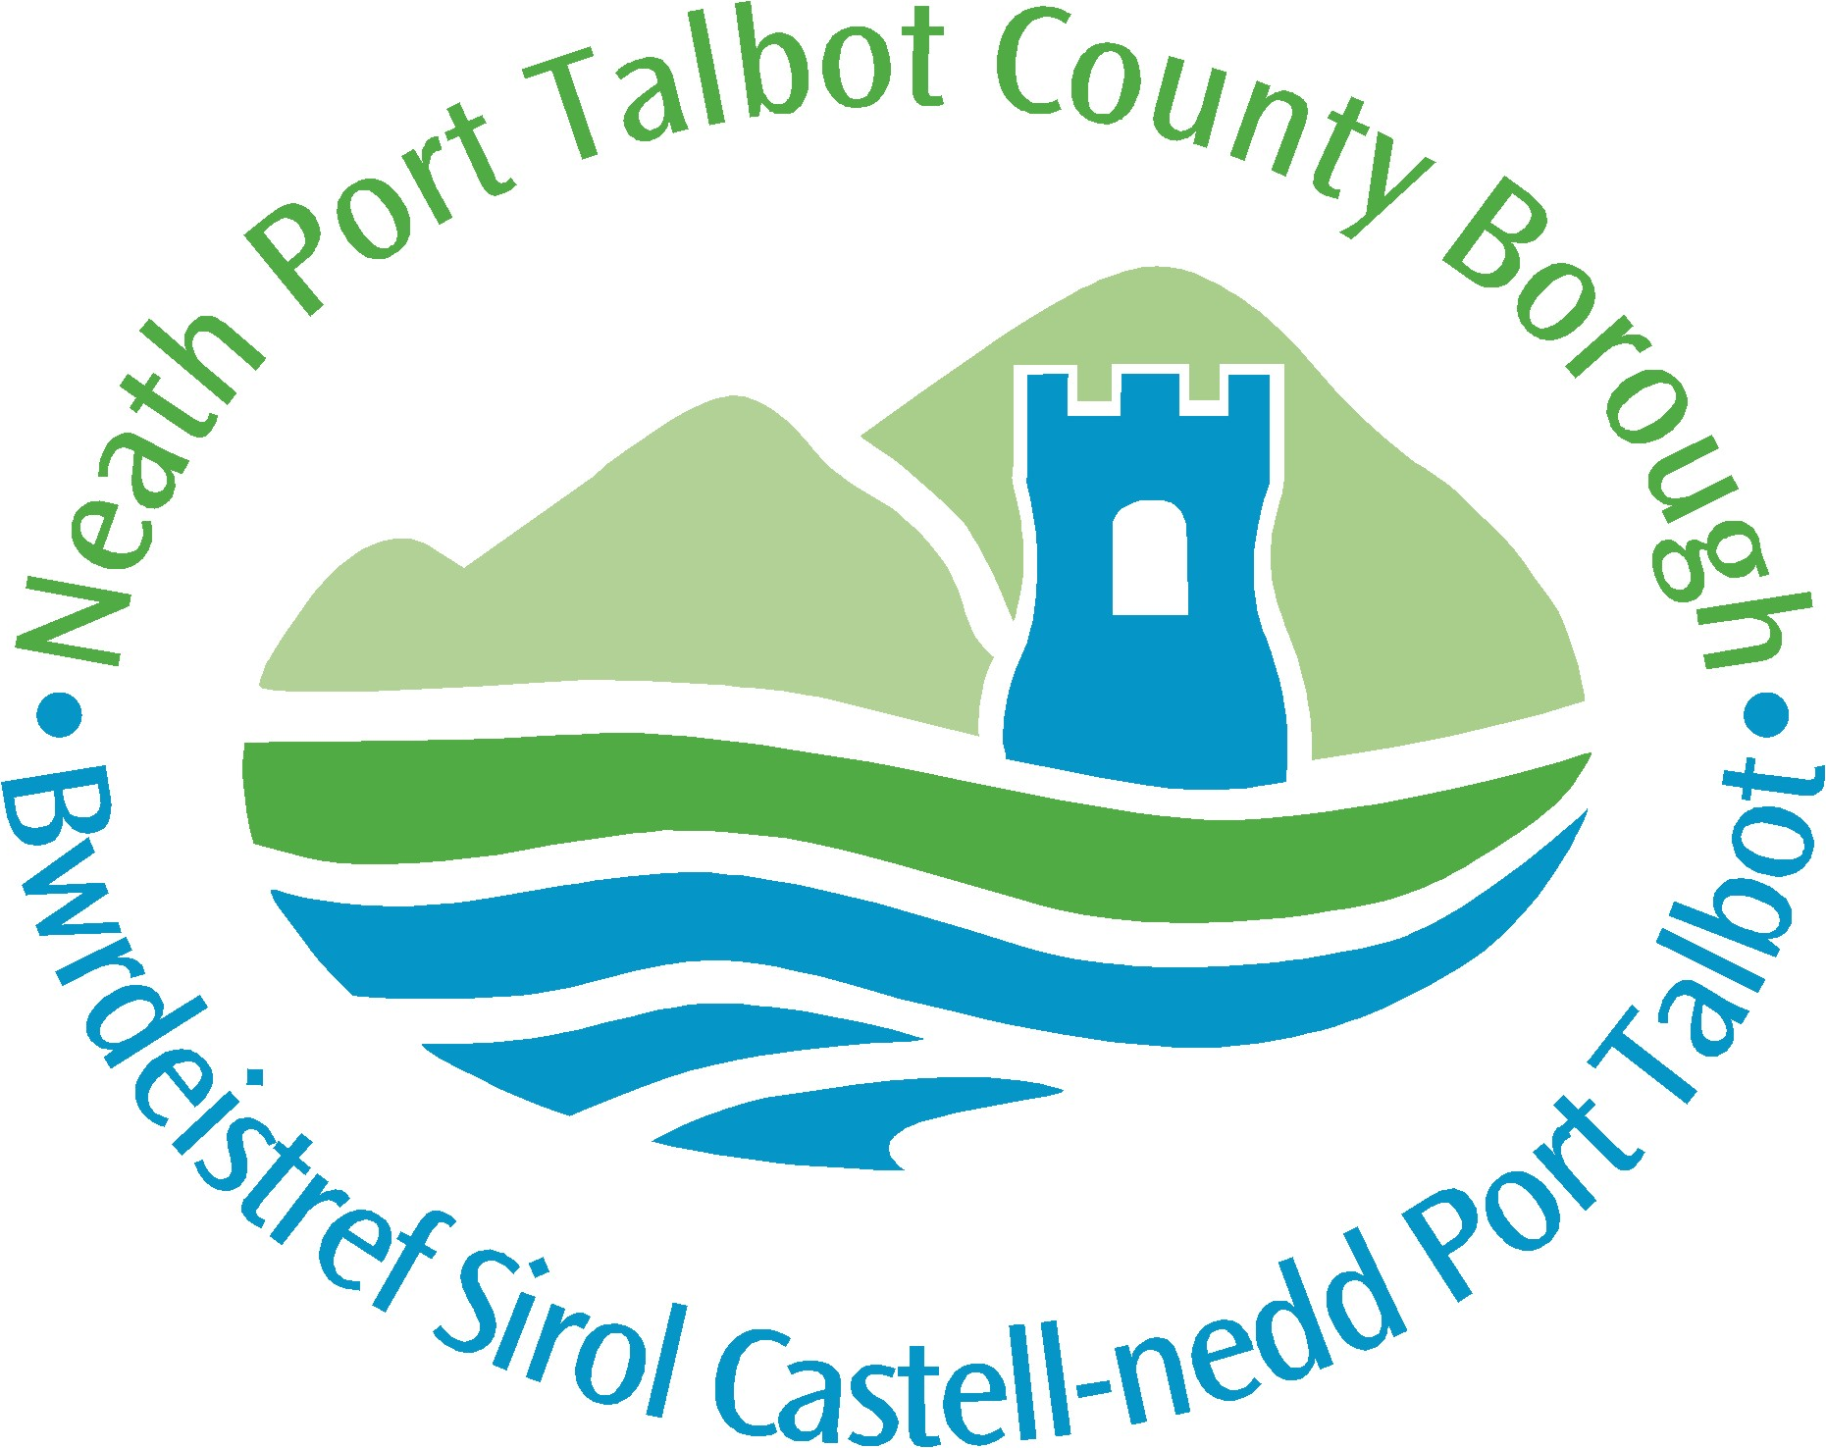
  - Accreditation Workshop
Wednesday 28th June 2017
St Paul’s Centre, Gerald St, Port Talbot SA12 6DQ

08:30 – 09:00 Registration / Refreshments
09:00 Start & Introduction - RGE Associates
09:10 – 09:40 Overview and mapping of the various Accreditation standards
RGE Representative with interactive sessions
09:40 – 09:50 Video presentation
09:50 – 10:10 Questions and Discussion
10:10 – 10:40 Tea / Coffee – One to One Sessions
10:40 - 11:10 Benefits – Route to Accreditation
        - Foundations
The workshop is suited to Managers, Quality Managers (or deputy’s) and Business owners.

Return booking form to: Business@npt.gov.uk
Please mention in subject line – ACCREDITATION WORKSHOP
For further information about the event, please contact:
Neath Port Talbot Council – Business Team on 01639 68 68 35

For information or queries in relation to Accreditations, please contact:
Gary Evans gary@rgeassociates.com
Nerys Davies nerys@rgeassociates.com

        - Costs
        - Set up
        - Maintaining
11:10 – 11:20 Video Presentation
11.20 – 11.40 Questions and Discussion
11:40 – 12:00 Tea / Coffee
12:00 – 12:30 One to Ones
12:30 Session Close

  - Booking form
Accreditation Workshop - Wednesday 28th June 2017

Course Details Please write in BLOCK CAPITALS.
Title | Accreditation Workshop
Date | Wednesday 28th June 2017
Venue | St Paul’s Centre, Gerald St, Port Talbot SA12 6DQ  Phone: 01639 883123
Return booking form to: | Business@npt.gov.uk  Please mention in subject line – ACREDITATION WORKSHOP
Notes | Please provide an email address in order to provide confirmation of booking. Bookings must be received by Wednesday 21st June 2017 (Maximum of 30 places)

Your Details
Title | Mr Mrs Miss Ms Dr other
Surname
Forename
Job title/discipline

Organisation Name and business address
Phone number:
E-mail
Size of Business? | Small, Medium or Large | Number Employed:
Business Sector? | e.g: Manufacturing
Do you currently hold any form of Accreditation?
What form of Accreditation/s are you interested in taking on?

Independent equal access
I have a disability. Please contact me to discuss my requirements (Please tick if applicable)

Dietary requirements
Please state any special dietary requirements below:

Confidentiality: All information is treated with the strictest of confidence by NPTCBC and will only be shared with the workshop providers and the Port Talbot Waterfront Enterprise Zone team at Welsh Government.

