
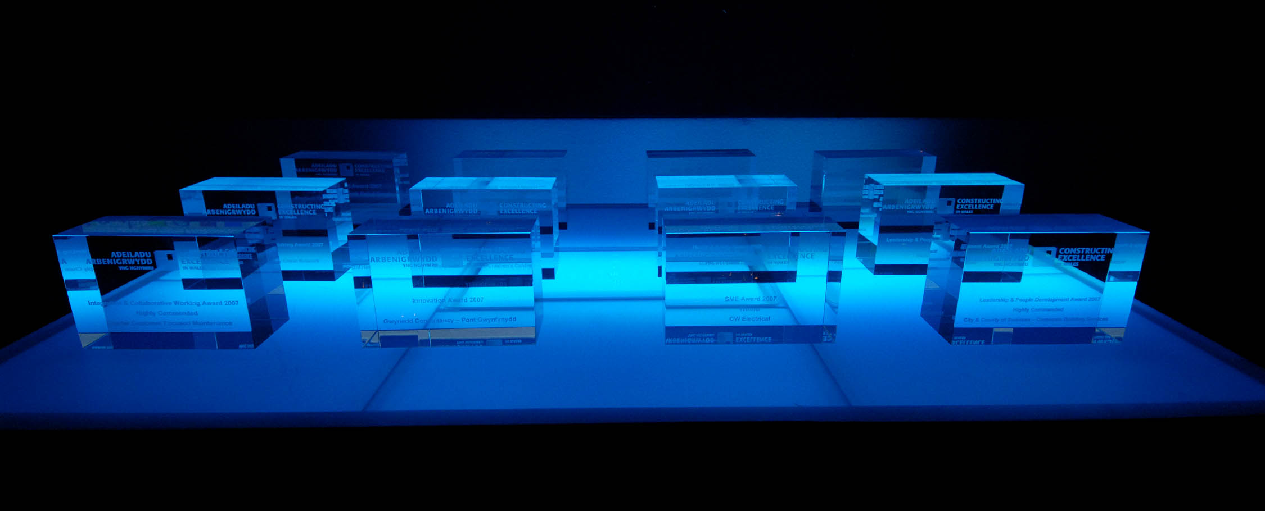

AWARDS 2016
Friday 15th July
Celtic Manor, Newport

Table Reservation

I would like to purchase ticket(s) priced at £85 (plus VAT) each
or
I would like to purchase table(s) of 10 priced at £850 (plus VAT) each

Contact Name: |  |  | Surname:
Organisation:
Position:
Address:
Post Code:
Email:
Phone: |  |  |  | Fax:
Nature of Business:

Please note payment must be made in advance and tables are not confirmed until payment has been received.

I enclose a cheque for £ made payable to
Constructing Excellence in Wales

Please send me an invoice made out to:

I wish to pay by credit/debit card (a charge will apply) please contact for card
details.

Return completed booking form and payment to:

Constructing Excellence in Wales
2nd Floor East Tel: 02920 493322
Longcross Court
47 Newport Road Fax: 02920 493233
Cardiff CF24 0AD Email: awards@cewales.org.uk

