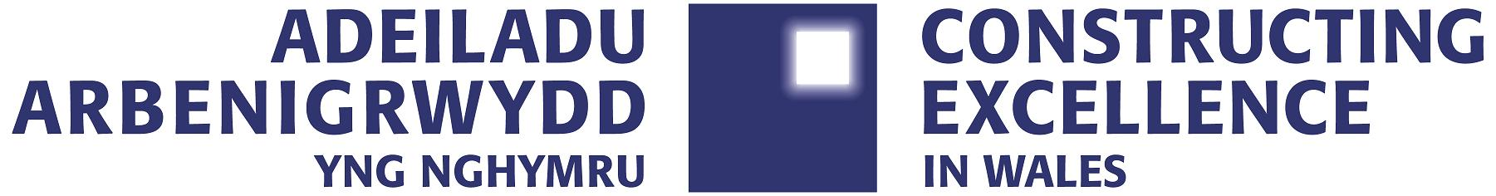

Entry Form
SME of the Year 2018

Ensure you read and understand the criteria and guidelines before completing this form. Guidelines on ‘How to Enter’ can be found at http://www.cewales.org.uk/cew-awards/ importantly, please remember that:

- Information above the specified word limits will not be taken into consideration.
- Photos and logos (of all companies involved) in a high resolution format must accompany every entry. These can also be embedded into the document.

- Please submit your completed entry form by post or hand deliver to Susan Selkirk, Office Manager, Constructing Excellence in Wales, 2nd Floor East, Longcross Court, 47 Newport Road, Cardiff, CF24 0AD by the closing date of
Monday 26th February 2018 at 17.00.

- Appendices will not be reviewed as part of the submission.

Category Description: SME of the Year
SMEs are the backbone of the industry and are recognised by Constructing Excellence for their dominance of and contribution to the supply chain. Department for Business Innovation and Skills suggest that 99.9% of UK construction contracting businesses are SMEs¹ and some of the greatest innovation and best practice can be identified in this sector.Judges are looking for an exemplary organisation, with 249 or less employees and with turnover less than £42 million. An outstanding SME will display the following organisational attributes:
- Evidence of growth through engaging with and developing best practice in construction and organisational management.
- Demonstrate how Investment is made in employees, through training, growth and organisational culture.
- Taking action to improve their productivity and work smarter.
- Showing how they have engaged with their supply chain, both upward to their clients and downwards to their suppliers, to add value to their involvement in projects.
- Evidence that they have development and performance targets in place and show monitoring and management of performance to improve on their set goals.
(1 ref BIS UK Construction) Categories: 1 – 50 or 51 – 249 employees

Entry Form
SME of the Year

SECTION 1
Entry name
(Please keep this concise)
This name will be etched on the award if successful

Applicant’s contact details | Name
 | Organisation
 | E-mail
 | Telephone
 | Address
 |  | Postcode:
 | Number of employees

SECTION 2: Your submission
Background
Please provide a brief and compelling summary describing the circumstances or challenges faced (maximum 250 words)
How have you engaged with and developed best practice?
(maximum 250 words)
How have you invested in your employees?
(maximum 250 words)
How have you improved workforce productivity and smarter working?
(maximum 250 words)
How have you engaged with your supply chain to add value to projects?
(maximum 250 words)
What development and performance targets do you have and what is your performance against them?
(maximum 250 words)
What makes this submission a winning entry? Why do you think this work stands out from the crowd and how do you suggest we share this with the industry?
(maximum 500 words)
Make sure you address the category criteria and ensure that the judges will understand:
Actions
What actions were taken to deliver outstanding outcomes?
Impact
What results were achieved and what evidence can you provide?
Lessons learned
What lessons have been learned through this work and how have they been shared?
The Constructing Excellence Awards ‘recognise the best and inspire the rest’.

What makes your submission special? We want to know if you are doing something that is new or different. Or if are you doing something that is common to the industry, but doing it better than anyone else. It could be how you manage a specific process or a wide ranging programme. It doesn’t need to be technologically cutting edge, but it does need to be exemplary.

Can you demonstrate real benefits? We want data. You needn’t submit all your information but we need to know that you have changed or achieved something through some measurable information. Did you do it cheaper, better or with increased satisfaction to your clients?
Is it honest? We are not looking for marketing information. We want real stories which give an honest summary of all the issues that you have overcome to deliver.

Check list:
Your entry should consist of:
  - Completed entry form – this is the only document used in the first stage of the judging process.
  - Logos for all key parties that should be recognised in connection with any award (original .eps files for print)
  - High resolution images (print quality) – up to 5 photos. Logos and images are used for publicity purposes.

Contact: Susan Selkirk on 02920 493322 or email Susan.Selkirk@cewales.org.uk

